A Review of Audio Classification using Machine Learning: A Systematic Literature Review
Project Echo

Audio Classification using Machine Learning: A Systematic Literature Review
Audio classification in the scope of our project will be to unobtrusively classify the different types of species in a rainforest. However, one of the benefits of using AI / ML to classify a specific type of data, is that it can easily be transferred to data in a completely different domain – using some fine-tuning techniques. For example, models developed for the research of cardiovascular diseases using audio samples of the heart [1] can be translated and slightly adjusted to fit the domain of audio samples of sound producing animals using transfer learning techniques.
A recent survey [2] examining the impact of the dataset size and number of classes on the accuracy obtained from acoustic classification shows a correlation between the two values:
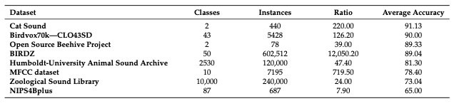
Figure 1 Bioacoustics dataset and classification accuracy [2]

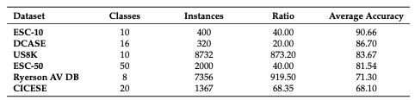
Figure 2 General Acoustics dataset size and classification accuracy [2]

An analysis of the studies that mentioned preprocessing revealed the most popular audio transformation technique as STFT (short-time Fourier transform) among both the bioacoustic and general acoustic studies [3] [4] [5] [6]. STFT breaks a signal into several signals of shorter duration and then transforms them into frequency domains. The other popular technique mentioned was constant-Q transform (CQT) which was used in both Bioacoustic analysis and general acoustic studied. It transforms a data series into a frequency domain. The FFT was also popular mainly in bioacoustic studies.

Feature extraction helps derive the audios short-time energy, zero-crossing rate, and bandwidth, among other useful features when classifying sound. Mel frequency cepstral coefficients (MFCCs) use the MEL scale to divide the frequency band into sub-bands and then extract the Cepstral Coefficients using a discrete cosign transform (DCT).

Machine learning algorithms: The survey showed that ensemble approaches are the most popular machine learning algorithms use in bioacoustics classification. Convolutional neural networks (CNN) were the most popular algorithms for general acoustic classifications. The choice of classifiers was motivated by the performance of similar classification tasks from previous studies. Bayesian [7] and hidden Markov models [8] showed the best accuracy levels for bioacoustic sounds, however only a few studies used them – due to higher computational cost and greater statistical expertise required. CNN algorithms and ensemble approaches were more poplar; however, they had slightly lower accuracy (87-88%).

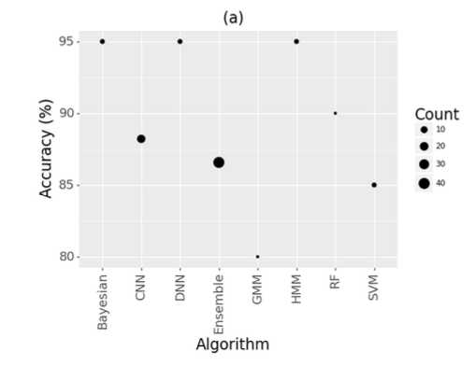
Figure 3 classification algorithms used for Bioacoustic and general acoustic studies [2]

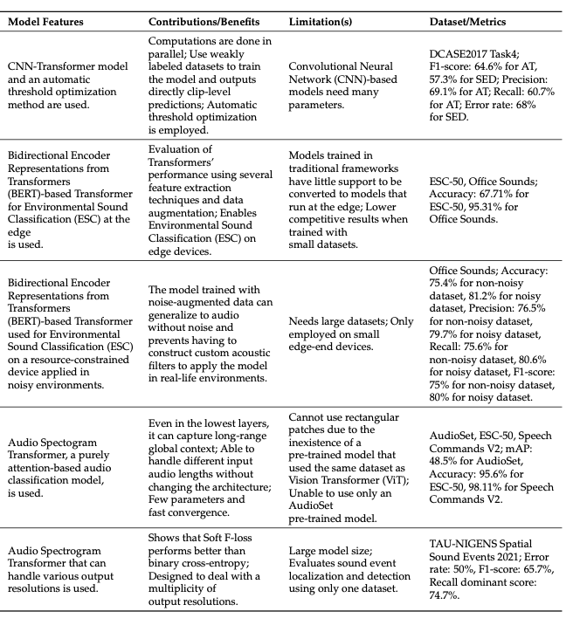
Figure 4 Review of lit [9]
Some researchers created models with a hybrid architecture combining transformers with Convolutional Neural network like Kong et al. [10], proposing a CNN-Transformer and an automatic threshold optimization method. Others focused on models based only on Transformers, presenting Bidirectional Encoder Representations from Transformers (BERT) based models capable of performing sound classification.
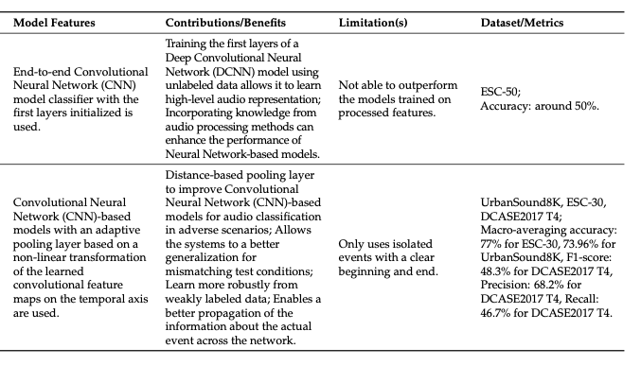
Figure 5 review of lit [9]
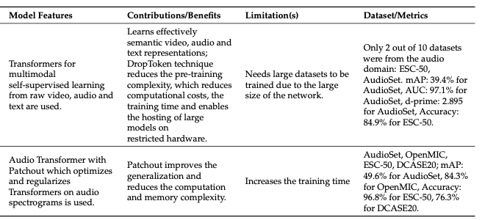
Figure 6 review of lit [9]

Researchers have shown that seep features include more significant information than handcrafted features, which translates into better results. To further improve the models’ performance, researchers have implemented attention mechanisms that allow focusing on the semantically relevant characteristics. Therefore, the following section is focused on studies that implements different attention mechanism.

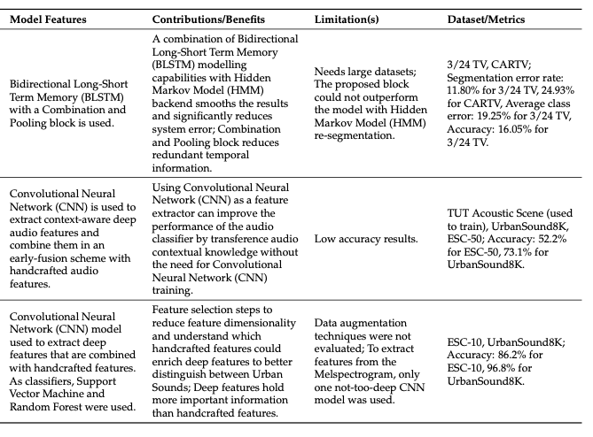
Figure 7 review of lit [9]

The study presented by Zhang et al. (2019) [11] incorporated temporal attention and channel attention mechanisms. His proposal used a Convolutional Recurrent Neural Network (CRNN) model of eight convolution layers to learn high-level representations from the input log-gammatone spectrogram. The channel temporal attention mechanism enhanced the representational power of CNN. Then, two layers of Bidirectional Gated Recurrent Unit (B-GRU) were used to learn the temporal correlation information, to which the CNN learned features were given as input. Finally, SoftMax was used as activation function for the classification task.
Tripathi and Mishra [12] introduced an attention-based Residual Neural Network (ResNet) model that efficiently learns Spatio-temporal relationships in the spectrogram, skipping the irrelevant regions. They also used time shift, adding noise and Spec Augment.

Potential methods and techniques for Project Echo

Late Fusion
Some researchers have implemented a late fusion technique to combine several different classifiers resulting in improved accuracy. [6] [13] [14] [15] The approach is to train a deep learning classifier e.g. CNN with some spectrogram representation, along with training some other traditional ML algorithms such as k-means clustering using different features of the same dataset. The predictions given by all the models are then summed at the end to enhance the accuracy of the predictions.

Data Augmentation
To improve the accuracy of the ML model some researchers [16] [17] [18] have augmented the training data by slightly varying the either the raw audio (e.g. clipping, speeding up, adding noise etc.) or the spectrogram (summing two spectrograms in the same class, shifting the pitch and time axis or warping the image). This approach will probably be necessary to address overfitting as we have a limited data pool.

Audio only training
Generating spectrograms can be time intensive, as it is processed with CPU and cannot be sped up with GPU, thus creating a bottleneck. Most studies use some form of spectrograms as a way to reduce the dimensionality but there exist methods that train using raw audio data. [7] Using SincNet, a CNN that learns the audio filters needed for dimensionality reduction, an accuracy comparable to image based models trained on spectrograms can be obtained.

Bibliography

[1] | S. Sahoo, P. Dash and B. Mishra, "Deep learning-based system to predict cardiac arrhythmia using hybrid features of transform techniques," Intelligent Systems with Applications, vol. 16, 2022.
[2] | L. Mutanu, J. Gohil, K. Gupta, P. Wagio and G. Kotonya, "A Review of Automated Bioacoustics and General Acoustics Classification Research," Sensors, vol. 22, no. 21, p. 8361, 2022.
[3] | C. I. Kim, Y. Cho, S. Jung, J. Rew and E. Hwang, "Animal sounds classification scheme based on multi-feature network with mixed datasets," KSII Transactions on Internet and Information Systems, vol. 14, no. 8, pp. 3384-3398, 2020.
[4] | L. Nanni, S. Brahnam, A. Lumini and G. Maguolo, "Animal Sound Classification Using Dissimilarity Spaces," Applied Sciences, vol. 10, no. 23, p. 8578, 2020.
[5] | S. Gunasekaran and K. Revathy, "Content-Based Classification and Retrieval of Wild Animal Sounds Using Feature Selection Algorithm," in Second International Conference on Machine Learning and Computing, Bangalore, 2010.
[6] | J. Noda, C. Travieso and D. Sanchez-Rodriguez, "Methodology for automatic bioacoustic classification of anurans based on feature fusion," Expert Systems with Applications, vol. 50, pp. 100-106, 2016.
[7] | M. R. Hossain, N. B. English, S. T. Moore and M. R. Hossain, "Bioacoustic classification of avian calls from raw sound waveforms with an open-source deep learning architecture," Scientific Reports, vol. 11, p. 15733, 2021.
[8] | C. Bergler, R. X. Cheng, V. Barth, M. Weber, H. Schröter, E. Nöth, H. Hofer and A. Maier, "ORCA-SPOT: An Automatic Killer Whale Sound Detection Toolkit Using Deep Learning," Scientific Reports, vol. 9, p. 10997, 2019.
[9] | A. F. Rodrigues Nogueira, H. S. Oliveira, J. J. Machado and J. M. R. S. Tavares, "Sound Classification and Processing of Urban Environments: A Systematic Literature Review," Sensors, vol. 22, p. 8608, 2022.
[10] | Q. Kong, Y. Xu, W. Wang and M. D. Plumbley, "Sound Event Detection of Weakly Labelled Data with CNN-Transformer and Automatic Threshold Optimization," IEEE/ACM Transactions on Audio, Speech, and Language Processing, vol. 28, pp. 2450-2460, 2020.
[11] | Z. Zhang, S. Xu, S. Zhang, T. Qiao and S. Cao, "Learning Attentive Representations for Environmental Sound Classification," IEEE Access, vol. 7, pp. 130327-130339, 2019.
[12] | A. M. Tripathi and A. Mishra, "Environment sound classification using an attention-based residual neural network," Neurocomputing, vol. 460, pp. 409-423, 2021.
[13] | J. Xie and M. Zhu, "Handcrafted features and late fusion with deep learning for bird sound classification," Ecological Informatics, vol. 52, pp. 74-81, 2019.
[14] | J. Salamon, J. P. Bello, A. Farnsworth and S. Kelling, "Fusing Shallow and Deep Learning for Bioacoustic Bird Species Classification," 2017 IEEE International Conference on Acoustics, Speech and Signal Processing (ICASSP), pp. 141-145, 2017.
[15] | MathWorks, "Acoustic Scene Recognition Using Late Fusion," 2022. [Online]. Available: https://au.mathworks.com/help/wavelet/ug/acoustic-scene-recognition-using-late-fusion.html.
[16] | Y. R. Pandeya, D. Kim and J. Lee, "Domestic Cat Sound Classification Using Learned Features from Deep Neural Nets," Applied Sciences, vol. 8, no. 10, p. 1949, 2018.
[17] | L. Nanni, G. Maguolo and M. Paci, "Data augmentation approaches for improving animal audio classification," Ecological Informatics, vol. 57, p. 101084, 2020.

